**Sanity Testing Vs Smoke Testing: Introduction & Differences**

Smoke and Sanity testing are the most misunderstood topics in Software Testing. There is enormous amount of literature on the subject, but most of them are confusing. The following article makes an attempt to address the confusion.

The key differences between Smoke and Sanity Testing can be learned with the help of following diagram -

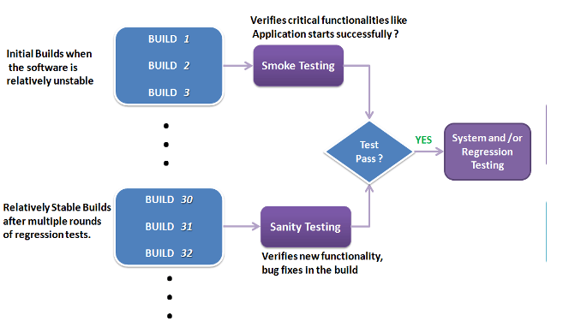

To appreciate the above diagram, lets first understand -

**What is a Software Build?**

If you are developing a simple computer program which consists of only one source code file, you merely need to compile and link this one file, to produce an executable file. This process is very simple.  
Usually this is not the case. A typical Software Project consists of hundreds or even thousands of source code files. Creating an executable program from these source files is a complicated and time-consuming task.  
You need to use "build" software to create an executable program and the process is called " *Software Build*"

**What is Smoke Testing?**

Smoke Testing is a kind of Software Testing performed after software build to ascertain that the critical functionalities of the program is working fine. It is executed "before" any detailed functional or regression tests are executed on the software build. The purpose is to reject a badly broken application, so that the QA team does not waste time installing and testing the software application.

In Smoke Testing, the test cases chosen cover the most important functionality or component of the system. The objective is not to perform exhaustive testing, but to verify that the critical functionalities of the system is working fine.  
For Example a typical smoke test would be - Verify that the application launches successfully, Check that the GUI is responsive ... etc.

**What is Sanity Testing?**

Sanity testing is a kind of Software Testing performed after receiving a software build, with minor changes in code, or functionality, to ascertain that the bugs have been fixed and no further issues are introduced due to these changes. The goal is to determine that the proposed functionality works roughly as expected. If sanity test fails, the build is rejected to save the time and costs involved in a more rigorous testing.

The objective is "not" to verify thoroughly the new functionality, but to determine that the developer has applied some rationality (sanity) while producing the software. For instance, if your scientific calculator gives the result of 2 + 2 =5! Then, there is no point testing the advanced functionalities like sin 30 + cos 50.

**Smoke Testing Vs Sanity Testing - Key Differences**

|  |  |
| --- | --- |
| **Smoke Testing** | **Sanity Testing** |
| Smoke Testing is performed to ascertain that the critical functionalities of the program is working fine | Sanity Testing is done to check the new functionality / bugs have been fixed |
| The objective of this testing is to verify the "stability" of the system in order to proceed with more rigorous testing | The objective of the testing is to verify the "rationality" of the system in order to proceed with more rigorous testing |
| This testing is performed by the developers or testers | Sanity testing is usually performed by testers |
| Smoke testing is usually documented or scripted | Sanity testing is usually not documented and is unscripted |
| Smoke testing is a subset of Regression Testing | Sanity testing is a subset of Acceptance testing |
| Smoke testing exercises the entire system from end to end | Sanity testing exercises only the particular component of the entire system |
| Smoke testing is like General Health Check Up | Sanity Testing is like specialized health check up |

**Points to note.**

* Both sanity tests and smoke tests are ways to avoid wasting time and effort by quickly determining whether an application is too flawed to merit any rigorous testing.
* Sanity Testing is also called tester acceptance testing.
* Smoke testing performed on a particular build is also known as a build verification test.
* One of the best industry practice is to conduct a Daily build and smoke test in software projects.
* Both smoke and sanity tests can be executed manually or using an automation tool.  When automated tools are used, the tests are often initiated by the same process that generates the build itself.
* As per the needs of testing, you may have to execute both Sanity and Smoke Tests on the software build. In such cases, you will first execute Smoke tests and then go ahead with Sanity Testing. In industry, test cases for Sanity Testing are commonly combined with that for smoke tests, to speed up test execution. Hence, it's a common that the terms are often confused and used interchangeably